University of Engineering and Technology

Lahore

- 212L: Semiconductor Devices Semester Project


1st Member: Filza Shahid
Roll No.: 2019-EE-151

2nd Member: Zahra Fatima
Roll No.: 2019-EE-158

Submitted to: Ms. Sana Noor
Submitted on: February 21, 2021

Objectives:

In this lab we have to design a variable power supply of required specifications as provided in manual and suggest some improvement to the designed circuit.

Problem Statement:

Design and simulate a variable power supply which takes an AC input of 230V rms at 50 Hz and gives a DC output that can vary in the range of 0-30V and maximum output load current should be 1-1.5A.

Circuit Design:

Block Diagram:

The block diagram for an ordinary power supply is shown in figure
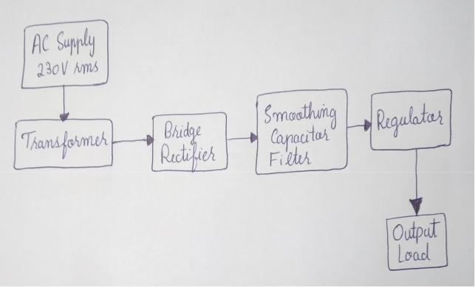

Block Diagram of Variable Power Supply

Design Explanation:

We are provided with 230V RMS sine wave as an input voltage. In order to decrease the voltage, we will use step down transformer. With the help of it, we will step down the voltage according to our requirements.

Then we attach a bridge rectifier which converts the AC voltage to pulsating DC. But still the achieved output is not perfect DC. It has ripples in it.

The ripple in the waveform are removed by using smoothing capacitor filter. Now this pulsating DC voltage is converted into Unregulated DC. Also, it still contains some ripples in it.

Now in order to regulate the voltage between 0-30V and making the waveform more smoother, we use LM317 IC which tolerates ripples and give smoother waveform. This unregulated DC voltage fed into a voltage regulator, will now keep a constant output voltage and suppresses unregulated voltage ripples.

At the reference pin of regulator, we use a potentiometer for the adjustment of resistance to give the required voltage at output. We also attach a resistor and a capacitor in parallel at output pin of Regu-lator. From here, we will record the output as DC waveform with low ripples across the load.

In order to control the flow of current and voltage, we se some diodes for this purpose. Here we are taking output across outer capacitor C4.

The most specific requirement in the circuit is that the voltage and current is controlled by resistor R3 whose value varies from 0-20k ohm which can be seen in the circuit diagram.

Design Calculation:

The calculations related to the design are as follows:-

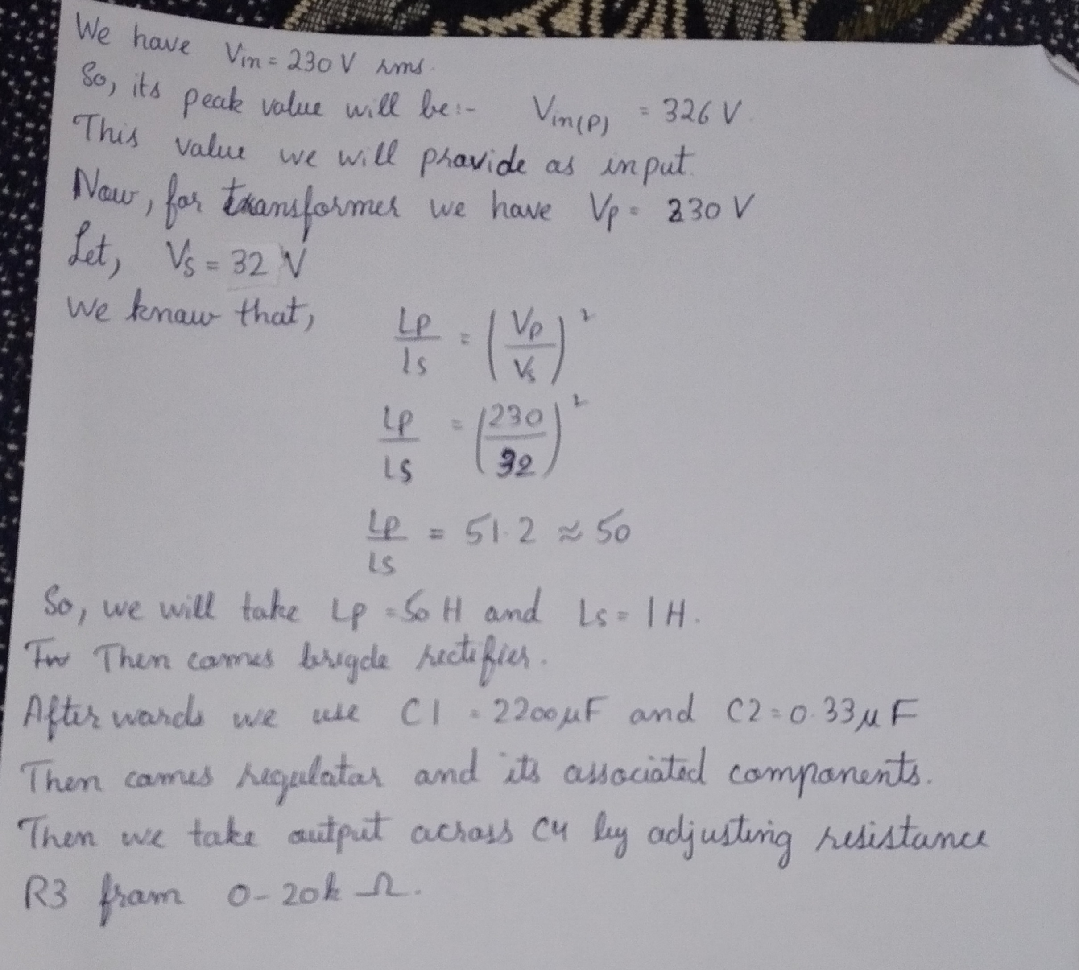

Calculations

Circuit Simulation:

The simulation of the circuit is done in proteus software. Here are required results and simulations.

Circuit Diagram:

Circuit diagram for the design of variable supply is as follows:-

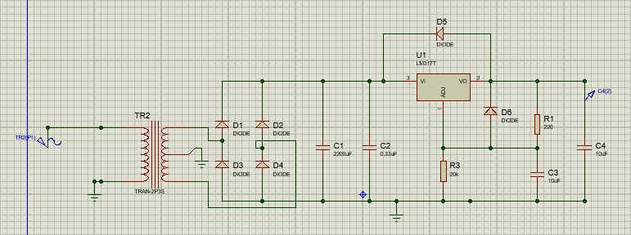

Circuit Diagram

Results:

By simulating the above circuit, we get the following results:-

Sr. No. | Vin rms  (V) | R3  (ohm) | Voutput  (V) | (Load Current  I (A)
1. | 230 | 1k | 7 | 1.04
2. | 230 | 5k | 29.1 | 1.06
3. | 230 | 10k | 29.8 | 1.07
4. | 230 | 15k | 29.9 | 1.09
5. | 230 | 20k | 30.0 | 1.09

Input and Output Waveforms:

Input and output waveform obtained from the circuit are as follows:-
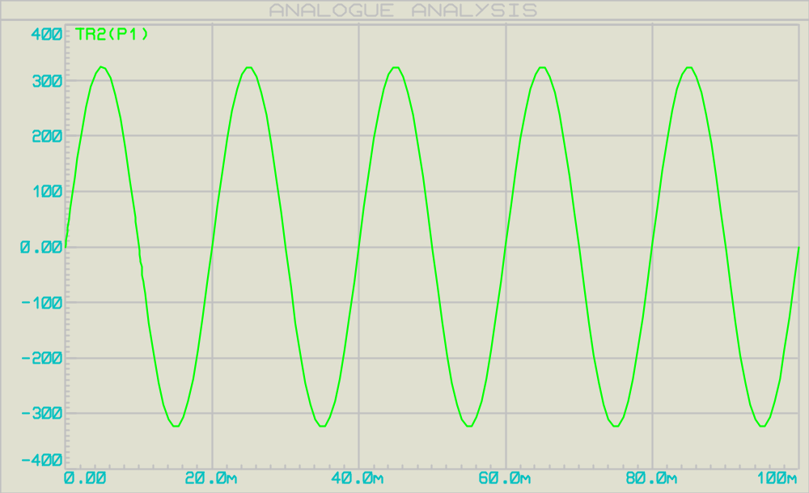

Input Sine waveform

When R3 value is 1k:-

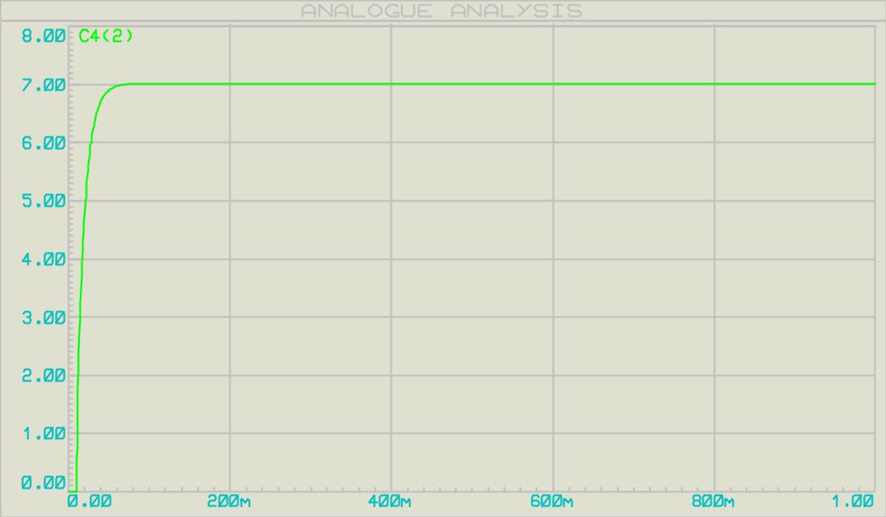

Output waveform

When R3 value is 5k:-

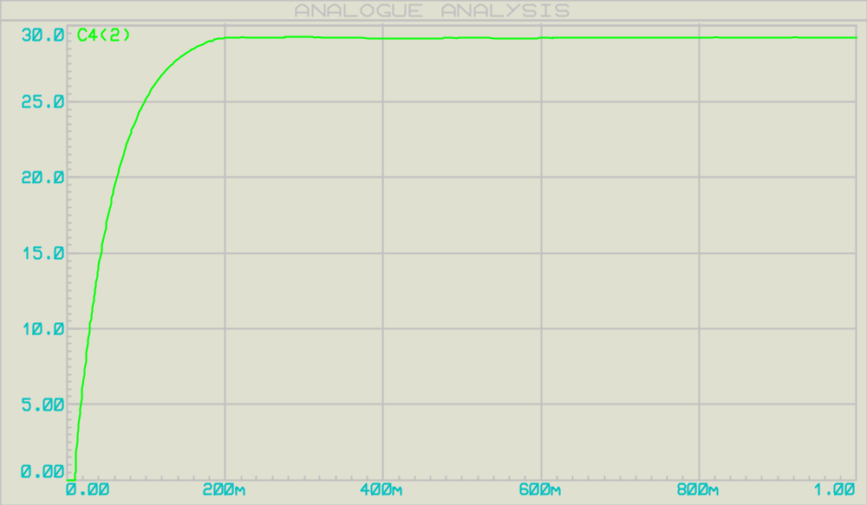

Output waveform

When R3 value is 10k:-

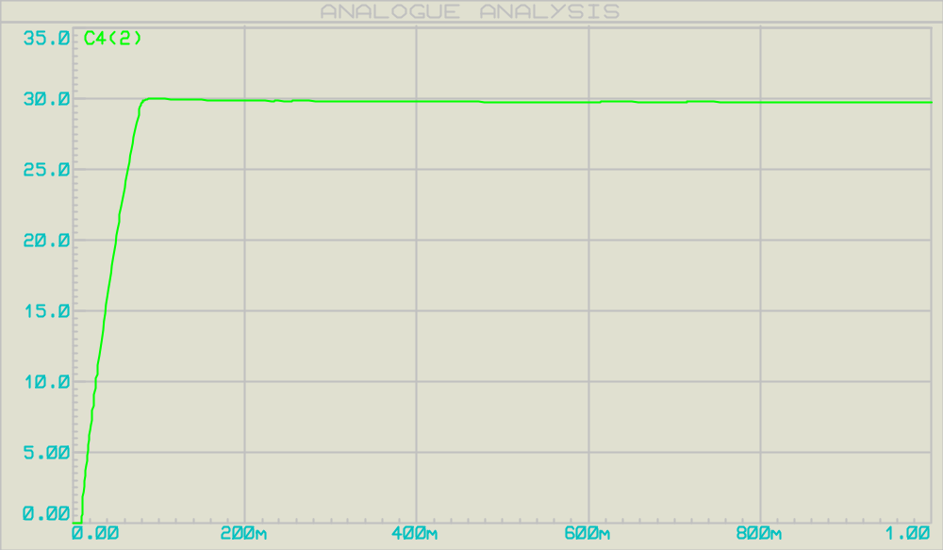

Output waveform

When R3 value is 15k:-

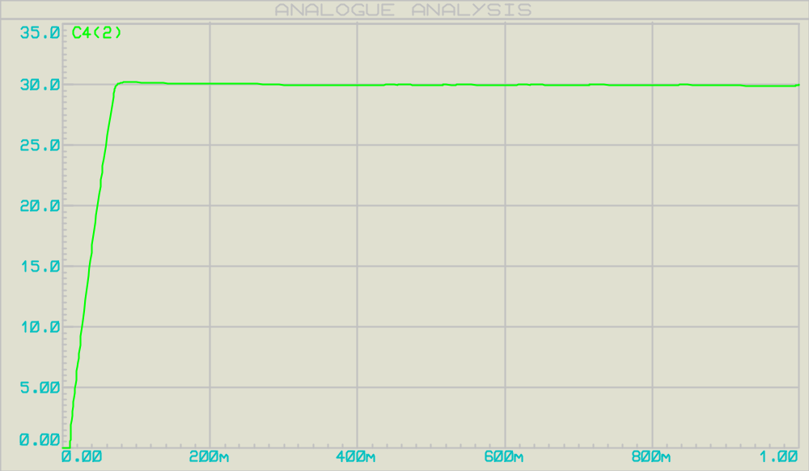

Output waveform

When R3 value is 20k:-

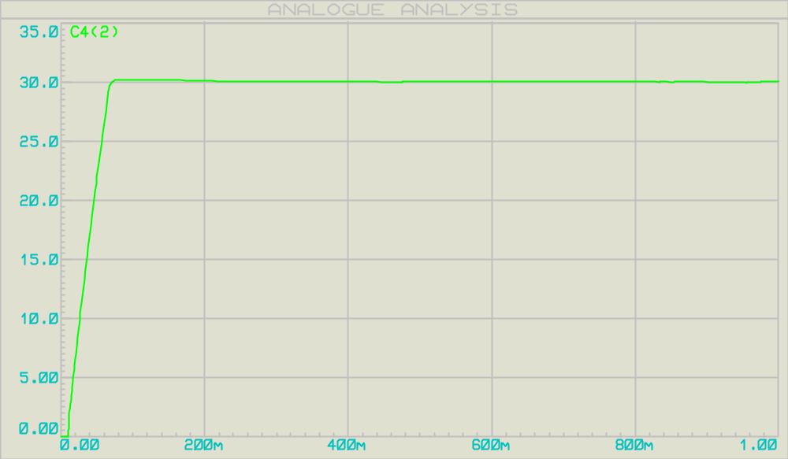

Output waveform

Conclusions and comments:

Although these are the necessary components for the regulator to work properly, adding some more elements not only improve the efficiency of the circuit but also provide added protection.

For example we can add more capacitor to reduce the ripples or more resisters to control the current flow. Diodes are used to protect the regulator from excess flowing through it if a battery or any other voltage source is connected across the output terminals of the regulator.

Power supplies deliver the voltage to each and every single component in the PC and make them work. It is the heart of the system and the provided electricity works like blood in the human body. If the delivered electricity is faulty or unstable it can ruin even the greatest high-end rig instantly.

